**DAILY ONLINE ACTIVITIES SUMMARY**

|  |  |  |  |  |  |  |  |  |
| --- | --- | --- | --- | --- | --- | --- | --- | --- |
| **Date:** | **05/06/2020** | | | | | **Name:** | **Lavanya D M** | |
| **Sem & Sec** | **4th & ‘A’** | | | | | **USN:** | **4al18cs041** | |
| **Online Test Summary** | | | | | | | | |
| **Subject** | | **Nil** | | | | | | |
| **Max. Marks** | | **Nil** | | **Score** | | | **Nil** | |
| **Certification Course Summary** | | | | | | | | |
| **Course** | **Making the puzzle game** | | | | | | | |
| **Certificate Provider** | | | **Bitdegree** | | **Duration** | | | **2days** |
| **Coding Challenges** | | | | | | | | |
| **Problem Statement:1) Write a Java Program to find the duplicate characters in a string**. 2) Write a program in Java to find out Alphabet and Diamond Pattern | | | | | | | | |
| **Status: complied** | | | | | | | | |
| **Uploaded the report in Github** | | | | | **yes** | | | |
| **If yes Repository name** | | | | | <https://github.com/lavanyamurthi/lockdown-coding> | | | |
| **Uploaded the report in slack** | | | | | **yes** | | | |

Online Test Details: (Attach the snapshot and briefly write the report for the same)

Certification Course Details: (Attach the snapshot and briefly write the report for the same)

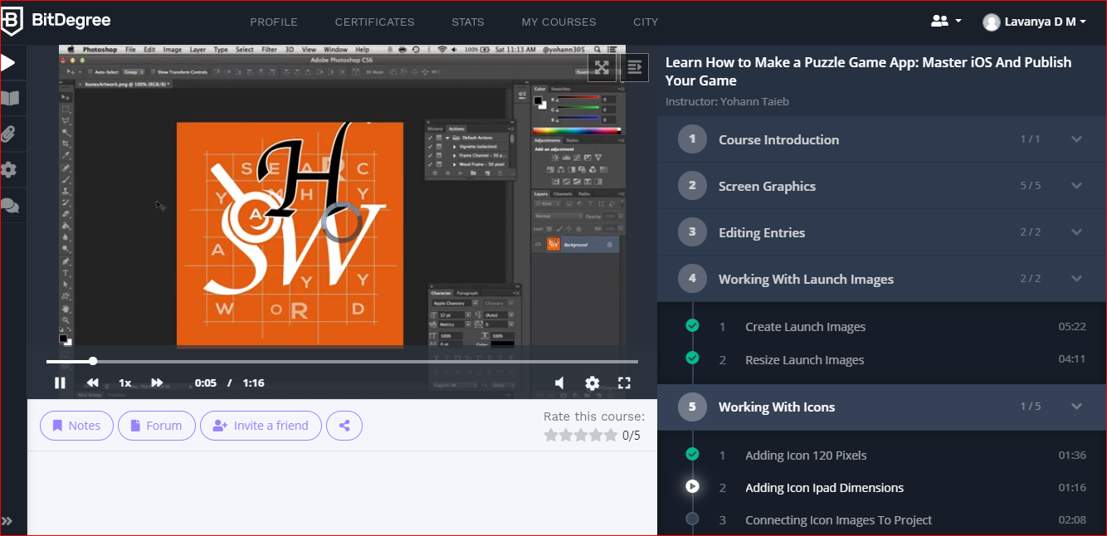

Today I learned about the launching images, resizing and even adding images etc

GitHub link <https://github.com/lavanyamurthi/lockdown-certificate>

Coding Challenges Details: (Attach the snapshot and briefly write the report for the same)

PROBLEM 1: **Write a Java Program to find the duplicate characters in a string.**

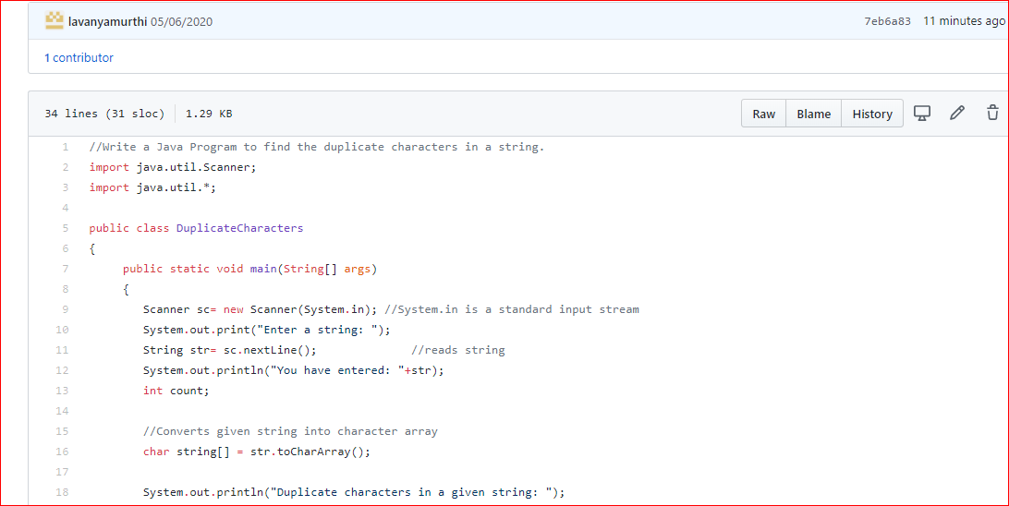

## Problem 2: Write a program in Java to find out Alphabet and Diamond Pattern

